**Game Specification**

**The Version of Unity:** 2020.3.29f1c1

**Operation:**

|  |  |
| --- | --- |
| D | Move “Player” towards the right side |
| A | Move “Player” towards the left side |
| W | Move “Player” forwards |
| S | Move “Player” backwards |
| Shift | Run |
| Spacebar | Pause the entire game and awake the menu |

**Build Settings:**

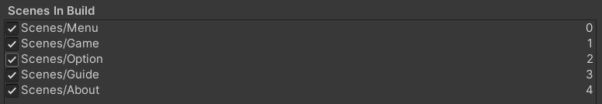

**Super Power:**

* **Speed Up (Yellow Particle Effect):** move speed is 21.0f, increase 20 SP per second.
* **Half Hurt (Blue Particle Effect):** each time the player is reached she/he loses 10 HP.
* **No Hurt (Red Particle Effect):** each time the player is reached she/he loses 0 HP.

Evade the enemy's pursuit.

The player can touch bases to get super power for avoiding enemy, at the beginning, players have 100HP, when he/she be reached by enemy will lose 20HP, when he/she in the dangerous area, every one second lose 2HP. Therefore, 0HP will game over.

Operation:

D: Move “Player” towards the right side.

A: Move “Player” towards the left side.

W: Move “Player” forwards.

S: Move “Player” backwards.

Shift: Add running speed.

Spacebar: Pause the entire game and awake the menu.